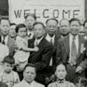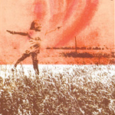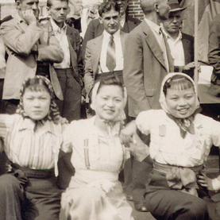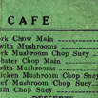
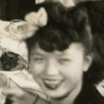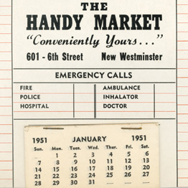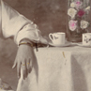
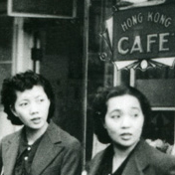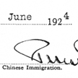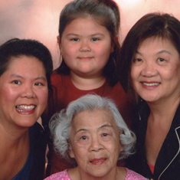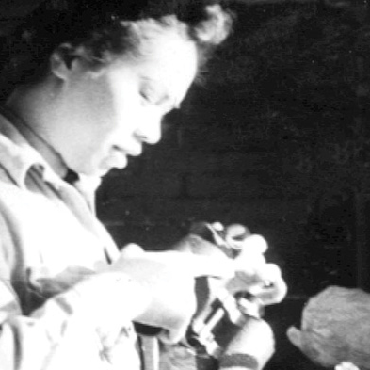
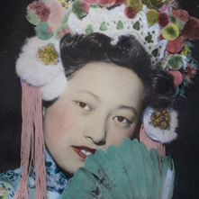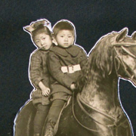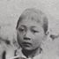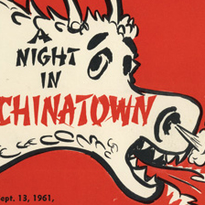

Top Row:
001_thumb
01bjl06Grace_thumb
MHSO_CWimage_HuneB1_thumb
046_thumb

2nd Row:
016_thumb
MHSO_CWimage_WongA6_thumb
MHSO_CWimage_Chew49_thumb
MHSO_CWimage_FongM2_thumb

3rd Row:
MHSO_CWimage_FilmG-2-6A_thumb (metadata sheet not finished)
MHSO_CWimage_WooJ12_thumb
MHSO_CWimage_LouByneA4_thumb
Mary-Ko-at-work_thumb

4th Row:
MHSO_CWimage_YehA9_thumb
MHSO_CWimage_LockK1page10_thumb
MHSO_CWimage_ChanS1_thumb
MHSO_CWimage_Chew71b_thumb

